**PRESS RELEASE**

**PLEDGE ON NASHA MUKT BHARAT ABHIYAN**

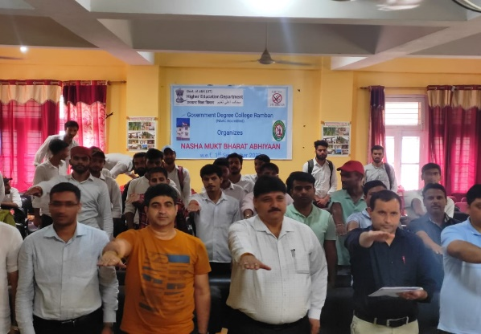**GDC RAMBAN:** As part of the Nasha Mukt Bharat Abhiyan, students and professors at GDC Ramban took pledge against drug abuse. The pledge taking ceremony was organised under the patronage of Principal of the College, Prof Subhash Chander Sharma. About 50 students and staff members took Pledge in which they stated their determination to make not only their neighbourhood, families, and friends drug-free, but also to abstain from all forms of substance misuse because drugs may ruin a person's life as well as destroy lives of their family and society. Keeping in mind the severity of the issue, the college will continue to host similar events in the future to protect our youth and society from the threat of substance abuse. Previously, the college organised a number of events to raise awareness among the students about the negative effects of drug abuse.

**SD/-**

**P R I N C I P A L**